PRESS RELEASE
FOR IMMEDIATE DISTRIBUTION
Bangkok, Thailand
25, March 2019

Tourism Students Celebrate the UN International Day of Happiness
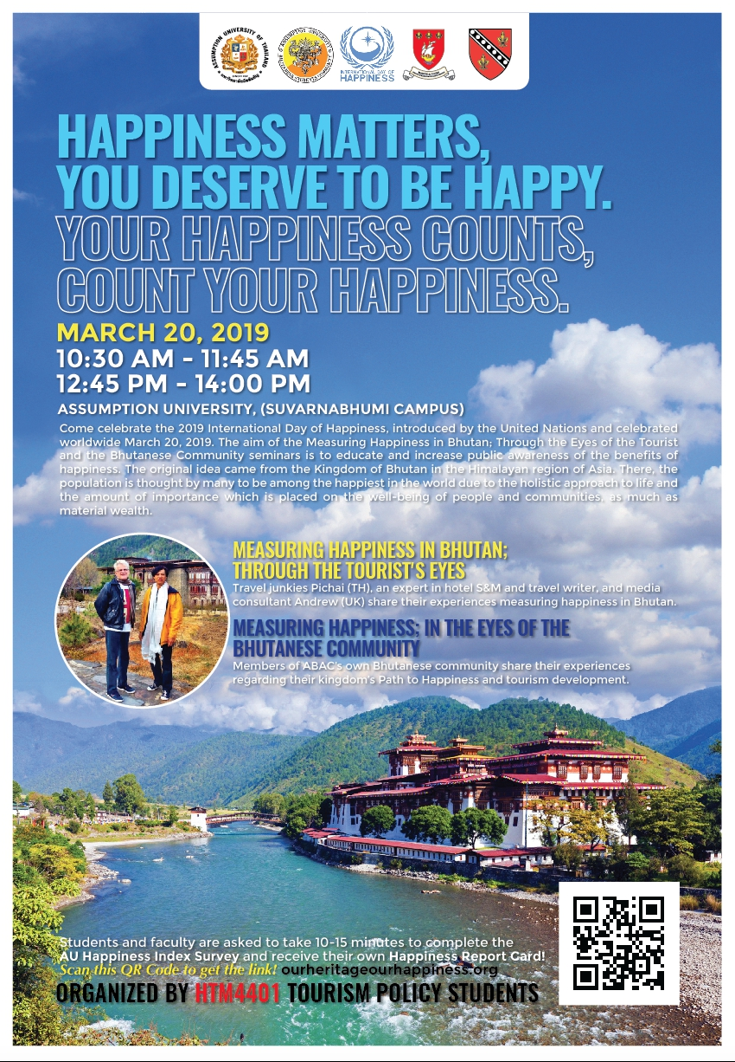
Assumption University’s Department of Hospitality and Tourism Management organized a special speaker’s series to Celebrate the International Day of Happiness
Assumption University’s Department of Hospitality and Tourism Management marked the United Nation International Day of Happiness with a special speaker’s session, 20 March, 2019 at Assumption University’s Suvarnabhumi campus. A lively panel discussion was held, focusing on Bhutan’s Gross National Happiness, led by travel journalist Andrew Wood and Assumption University Alumni Pichai Visutriratana. Bhutanese students studying at Assumption University shared their thoughts regarding sustainable tourism development in the kingdom of Bhutan.

The event was organized by Tourism Policy students and Dr Scott Michael Smith from Assumption University’s Department of Hospitality and Tourism Management. The “International Day of Happiness” recognizes happiness as the basic human goal and calls upon government and associated agencies to make policies towards improving peoples’ general well-being. The UN also acknowledges that social, environmental and economic well-being is mandatory for global happiness.

Dr Scott explains, “The International Day of Happiness is a time for all of us to consider our own happiness and think about paths that lead to happiness. With the help of Planet Happiness, students and faculty attending the seminar were encouraged to take a Happiness Survey and receive their own Happiness Report Card. The Planet Happiness project has two aims. The first relates to tourism and sustainability. It focuses on our understanding of the impact of tourism on the wellbeing of host communities in World Heritage sites. It aims to highlight and strengthen the relationship between tourism and the wellbeing of host communities. The second aim is to deliver a high impact media campaign that raises global awareness and participation in the Gross National Happiness (GNH) and “Beyond GDP” agenda.

Bhutanese student Mr. Thrizong Dawa Gyaltshen provided a historical context of Gross Domestic Happiness of Bhutan. In Bhutan, they calculate GNH using indicators such as sustainable development, environmental protection, effective government, social justice and the preservation of traditions. Student leader, Ms. Anna Purna Sharwma, shares the importance of ‘mindfulness’ as a key to happiness and suggests meditation as being an important part of her daily routine.

###
For further information
Dr Scott Smith, Assumption University Department of Hospitality and Tourism Management
Email: scottsmith@au.edu

Regarding Planet Happiness; Please email Paul Rogers PhD at paul@happycounts.org

